***Pre-Condition:*** Read and analyze the User Story details. If candidate has a smart phone, the use case described can be replicated by deleting the existing instance of Chase Mobile App (if they already have this installed), then re-install or install the Chase Mobile App from the App Store.

Story Name:  [Display dual log on screen after app install](https://jira-digital.jpmchase.net/browse/IOSS-686)

##### Value Statement

As Bank, I want to display alternate/ dual log on screen for the first time when user launches app after app install

##### Requirements

* Displayed for the first time after app install
* When user taps enroll, user will land on Basic Info screen.
* When user taps Log on, user will land on BAU (Business As Usual) logon screen
  + Anytime after using the app, when user returns to logon screen, the BAU logon screen is displayed
* Applies to Chase Spanish app also (Referenced in Spanish assets card).

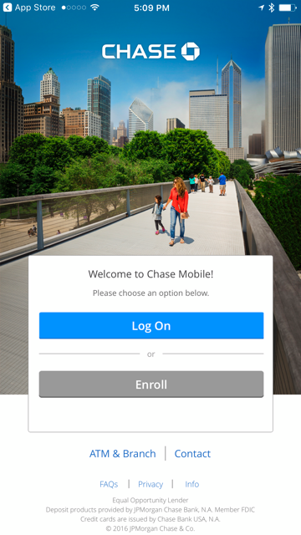

##### Acceptance Criteria

|  |  |  |  |
| --- | --- | --- | --- |
|  | Given | When | Then |
| 1 | User installs app | User launches app | Alternate log on screen is displayed  Note: Alternate logon screen does not have User Id/ Password fields, Enroll link, Forgot User Id or Password link and Remember me option |
| 2 | User is on alternate logon screen | User taps Enroll | Basic Info screen is displayed |
| 3 | User is on alternate logon screen | User taps Log On | BAU Logon screen is displayed |
| 4 | User views alternate logon screen first time | User taps 'Enroll' or 'Logon', closes app and launches app again | BAU Logon screen is displayed |
| 5 | User views alternate logon screen first time | User closes app without taking any action OR taps on any link other than 'Enroll' or 'Logon' and launches app again | Alternate log on screen is displayed |
| 6 | User updates app | User launches app | BAU Logon screen is displayed |
| 7 | User deletes and reinstalls app | User launches app again | Alternate log on screen is displayed |
| 8 | User launches app | Device language is set to Spanish | 'Welcome to Chase in Spanish' pop up is displayed - BAU before the corresponding logon screen is displayed |
| 9 | User is on alternate logon screen | App is in ECD/ Read Only/ Splash mode | Behavior of ‘FAQs’, ‘Branch locator’, ‘Contact Us’, 'Enroll' links should be BAU as they are today in those modes Note: Clicking on 'Log on' button on alternate logon screen should always take user to BAU logon screen |

***Assessment Question 1:*** Based on the User Story narrative above, list down at least **five** critical test scenarios / test cases to validate and sign off the story. List the test scenario name only, no details.

1. Display alternate login screen
2. User Updates App
3. User Enrolls
4. User Logs In to App
5. Display alternate logon in Spanish App.

***Assessment Question 2***: Pick 2 items from the Test Scenario list and create the actual gherkin test.

Feature: Display dual log on screen after install

Scenario: User Enrolls  
Given: User is on alternate logon screen  
When: User taps Enroll  
Then: Basic Info Screen is displayed.

Scenario: User Logs In to App  
Given: User is on alternate logon screen  
When: User taps Logon  
Then: BAU logon screen is displayed.

***Assessment Question 3:*** What are the different **locator strategies** to identify an element in Appium?

* Find by Class
* Find by Xpath
* Find by Id
* Name
* Link Text
* Partial text in link
* Tag name
* CSS selector

***Assessment Question 4:*** Consider HTML snippet below for an element whose id is changing dynamically in different executions as:

•         <input  name=ChaseBank1234454454> </input>

•         <input  name=ChaseBank90980989979> </input>

•         <input  name=ChaseBank_fdfdfdfdfdfddf> </input>

How do you handle the above situation and write a generic locator to match any of the above locators?

driver.findElement(By.partialLinkText(“ChaseBank”));